Honors U.S. History
Mr. Pond
Room 325
mpond@mrpond.org
www.mrpond.org
www.mrpondsushistory.blogspot.com
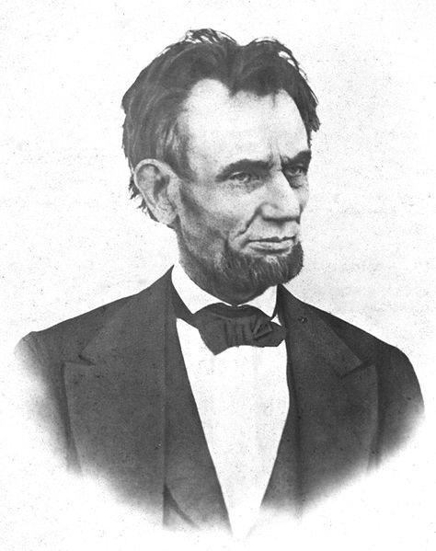

COURSE DESCRIPTION
In this course students will study U.S. History in order to become more knowledgeable of past events and historical time periods so that we can positively impact the future. During this course, we will take a journey through history in which we make relevant connections between the past and present. Through this, we will examine the social, cultural, political, economic and geographic forces that shaped the United States. Additionally, in this course, students will take the U.S. Constitution Test. U.S. History can be a fascinating exploration into our pasts especially when viewed from multiple perspectives.

GRADE COMPOSITION
- Quizzes There will frequently be written quizzes or projects which will count for 30-50 points each. Quizzes are often given at the start of the period so be sure to be on time. You will not be able to make up missed quizzes due to tardies.
- Class participation – We need your voice to be heard! You should come to class ready to participate fully in the topic of the day. Your class participation grade will be determined based on the following: Each day the student must bring all relevant class materials, contribute to the learning environment in a positive manner, be respectful of others, participate in the class discussion, complete classwork as assigned, and cooperate with partners in group work. Homework – Will be assigned regularly. Most assignments will be worth 10 points each unless specified by me. Many assignments and class work will be completed in your interactive notebook.
- Tests (including group and individual projects given a test weight) generally count for 100 points.
- Final Exams will count for 10% of your semester grade.
- Portfolio – will consist of your binder that includes all readings, handouts, homework assignments, participation points, notes…etc! In other words, you will be turning in everything you’ve done all year! What’s the point, you ask? This will help you keep your class materials organized and can provide you with a useful resource for AP or college classes (thank you for asking). Portfolios will be checked randomly every few weeks for a homework score and will be collected each quarter and graded for 30 points EACH quarter.

GRADING SCALE
90-100 % A
80-89 % B
70-79 % C
60-69 % D
59-0 % F

HISTORY FAIR
All U.S. History students will be competing in History Fair. This year’s theme is Revolution, Reaction, Reform in U.S. History. Students will first compete at a school-wide level against their peers and the winners of this opening round will have the option of competing at the regional level. Students in our state need to create projects with either a Chicago or Illinois connection to compete at the regional level. Students are allowed to compete in one the following categories:

- Exhibit
- Documentary
- Performance
- Research Essay
- Website

You will receive more information about history fair as the year goes on. Final projects will be worth 200 points, although there will be several benchmark points leading to your final effort. For more information on History Fair visit: www.chicagohistoryfair.org

CLASSROOM RULES:
- Be in your seat when the music stops.
- Discussion:
- One person speaks at a time.
- Be respectful of others opinions.
- Come prepared to participate in the discussion.
- Enjoy the discussion! We want and need to hear from you!!
- Bring your binder with all notes, handouts, graded papers, etc. to class EVERY DAY. Binders will be checked randomly and will be turned in as a final portfolio grade!
- The answer to “do we have to take notes on this?” is always “no,” but you probably should!
- Bring your book, binder, pen and notebook to each class. Participation points will be deducted for coming unprepared!

MATERIALS
You will need the following for EVERY class unless noted by the instructor:
- A People’s History of the United States 1492-Present
- Your interactive notebook (used only for this class)
- A 1.5”-2” black 3-ring binder* with folders
- Tabs for your binder
- Loose leaf lined paper
- A college or wide ruled notebook (recommended)
- A USB flash drive
- Blue or black ink pens (NO Red!)

*It is critical that you have your binder by the second week of class as you will receive many handouts during this course.

COURSE OUTLINE
- Unit One: The New World and its colonies; Revolution; Constitution
- Unit Two: The Young Republic
- Unit Three: Westward Expansion and Slavery
- Unit Four: The Civil War and Reconstruction
- Unit Five: Immigration and Industrialization in the Gilded Age
- Unit Six: Progressivism, War, and Depression
- Unit Seven: World War II and the Cold War
- Unit Eight: Civil Rights and Liberties
- Unit Nine: Modern America

LATE POLICY:
Assignments will be collected at the beginning of the period (this means assignments not printed or complete at the start of class are late!). If you do not have your assignment, or it is incomplete, you will need to fill out an Incomplete Assignment Form to take home to be signed by your parent. You may earn ½ credit for an assignment if you turn in the completed assignment the next class period with your signed Incomplete Assignment Form.

You are responsible for missed assignments caused by any absence; such missed work must be made up as soon as possible. You are responsible for scheduling a make-up examination. If you fail to do this, the grade will be recorded as a ZERO.

Typical homework assignments are worth 10 points each. Late homework may be turned in within one class period for half credit.

ESSAY REWRITING:
For nearly every test you will be expected to write an essay. You generally have the opportunity to rewrite that essay once your test has been returned. The score from your old essay will be averaged with the score from your new essay. This will be your new composite score. You will have ONE week from the day the tests are handed back to hand in your rewritten essay.

ACADEMIC INTEGRITY
Plagiarism or cheating of any kind will not be tolerated. In all cases of academic dishonesty NO CREDIT will be given for the work/test/quiz. Academic dishonesty includes: plagiarizing, copying a classmate’s work, possessing another student’s assignment, and other similar instances. By turning in original work you become a better writer, thinker and learner. Academic dishonesty will be handled according to LMSA policy.

CONTACT INFORMATION:
If you have a question, a comment, or are experiencing difficulty with this class please speak with me or email me at: mpond@mrpond.org. I will be available before and after school, and I am always willing to help. Many homework assignments and handouts can be downloaded from my website: www.mrpond.org. If you misplace a handout, please check the website or email me and download it to your flash drive or computer hard drive.

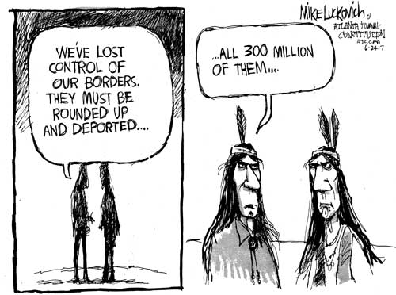
Source: http://www.truthdig.com/images/eartothegrounduploads/lkoriginalimmigration500.jpg

